Dunhuang UNESCO Global Geopark People’s Republic of China (Gansu)
Summary of work in 2018
1. Geopark Identity
Name, Country of the Territory and Regional Network:
Dunhuang UNESCO Global Geopark/China/ Asia-Pacific Geopark Network
Year of acceptance as UNESCO Global Geopark:2015
Annual Representative Events: Administration for Dunhuang UNESCO Global Geopark was established
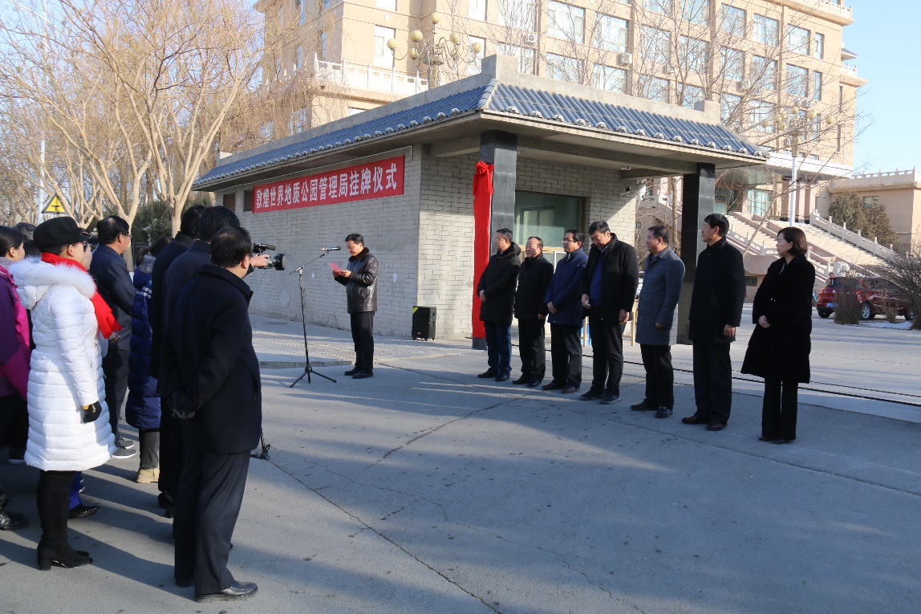
2.Geopark Data
Number of Staff: 83, Including five Geologists
Number of Tourists: In 2018, Dunhuang UNESCO Global Geopark received 10 million tourists.
Activity times: 5
Hold "4.22 World Earth Day" Publicity Week and Carry out Desert Wonders Picture Book Exchange; Organize training activities of evaluation work in Dunhuang UNESCO Global Geopark; Exchange and study activities with Yandangshan, Dali Mount Cangshan, Danxiashan and Keketuohai UNESCO Global Geopark; "Summit Forum of Greater Dunhuang Tourism Culture and Economy Circle" was held; We went to Hong Kong and Lanzhou with Dunhuang City Tourism Bureau to promote research tourism projects, etc.
Class Number of Schools Developing Geopark Education Program: 5
Number of press releases issued by Geopark: 4
3. Geopark activities
Major achievements in 2018:
1. The management system of each scenic spot of Dunhuang UNESCO Global Geopark has been completely straightened out. The separation of ownership, management right and operational authority of the scenic spot has been completed. Administration for Dunhuang UNESCO Global Geopark has been established. Accelerate the construction of national All-for-one tourism zone and realize the official operation of Dunhuang Tourism Distribution Center.
2. Geological protection and conservation and Infrastructure: Dunhuang Tourism Distribution Center has been put into operation. Dunhuang Villa North Charging Center has been built，with 266 new charging piles. The supporting parking lot and traffic operation reception system have been improved, and the Geopark's inbound and outbound capacity has been further enhanced. Yardang Scenic Spot cooperates with Dunhuang flyingapsara general aviation Co, LTD to launch the project of visiting Yardang by airplane. The Dunhuang Geopark Museum has opened a 5D cinema, which further enriches the visitor's experience model. Mount Mingshashan and Crescent Moon-shaped Spring Scenic Spot completed the construction of visitor rest shelter, Crescent Moon-shaped Spring fence and the purchase and installation of LED propaganda screen, and continued to dredge the scenic area wind channel, effectively alleviated the problem of Mount Mingshashan moving to Crescent Moon-shaped Spring, and maintained the long-term harmonious coexistence of them. What’s more, the sand in the Crescent Moon-shaped Spring seepage well is cleaned, the mountain body is monitored regularly, and the dynamic change of it is grasped in real time.
3. We will intensify environmental renovation of the Geopark and promote geological and ecological protection and management. Residents, agritainment and camping bases around the Geopark jointly protect resources and maintain tourism order.
4. Strengthen the external propaganda and cooperation and exchange of Dunhuang UNESCO Global Geopark, and fully display the tourism resources of Dunhuang UNESCO Global Geopark with the help of the platform of the Geopark network activities.
Contribution towards GGN--Network Activities and Participation:
- Participated in the 8th International Conference UNESCO Global Geoparks held by Adamello Brenta UNESCO Global Geopark, Italy.
- Participated in the 2018 China Global Geopark Annual Conference held in Yandang Mountain, Zhejiang Province, and won the right to hold the 2019 Annual Conference.
- Participated in The 4th International Training Course on UNESCO Global Geoparks.
- Launching Friendly Exchange and Learning Activities with Danxiashan, Dali Mount Cangshan, Yandangshan, Keketuohai and Alxa Desert UNESCO Global Geopark.
- Pay GGN dues on time.
Management and financial situation：
1. Administration for Dunhuang UNESCO Global Geopark has transferred the management and service items of Mount Mingshashan and Crescent Moon-shaped Spring, Yardang and Yumen Pass Scenic Spots to Dunhuang Culture&Tourism Group, and the supervision system has been fully straightened out. 2. The financial situation of the scenic spots of Dunhuang UNESCO Global Geopark is good.
Protection of Geoheritage：The Geopark’ geoheritage is protected and managed at different levels in strict accordance with the relevant requirements of Regulations on Geological Heritage Protection. Most of the geoheritage landscape in the Geopark are basically in the primitive natural state, not destroyed by human activities, only a few geosites are affected by natural weathering and bad weather.1. Continue to take isolation protection measures for important geosites in Yardang, and construct facilities such as walkways, guardrails and warning signs, etc. 2. In the Mount Mingshashan and Crescent Moon-shaped Spring, fencing and electronic monitoring system have been improved, groundwater level, Sand Mountain dynamics and wind monitoring equipment have been optimized, and ventilation channel dredging project of Mount Mingshashan has been implemented.
Sustainable tourism (geo-tourism): In 2018, the number of visitors to Dunhuang UNESCO Global Geopark reached 10 million, an increase of 19.8% over 2017. With the continuous promotion of the construction of Dunhuang Grand Scenic Spot, Yardang takes " Research Tour " as its theme, and urges the operating companies of the scenic spot to carry out various forms of publicity and promotion. Mount Mingshashan and Crescent Moon-shaped Spring Scenic Spot carries out standardization and rectification of camping base along the mountain desert, strengthens supervision and management of the scenic area and its surrounding areas during the tourism-peak season. At the same time, timely releases information on passenger flow, and guides travel agencies and tour guides to avoid rush hours to enter the Geopark. Sustainable development of tourism in the Geopark expands the tourist resources for hundreds of Farmhouse Inns around the Geopark, provides employment opportunities for tens of thousands of tourism service employees, and effectively promotes the sustainable development of Dunhuang's economy.
New educational programs on geoheritage conservation, sustainable development and disaster risk reduction:
1. To formulate and implement the "Five Entries" Program for Popular Science Education in Dunhuang UNESCO Global Geopark in 2018. 2. Promotional activities on 4.22 World Earth Day, 6.5 Environment Day and "Cultural and Natural Heritage Day" were carried out. 3. Launching "Summer Geoscience Camp 2018". 4. carrying out Dunhuang research tourism training activities in 2018.
Strategic Partners: 1. We work with China University of Geosciences, the Cold and Arid Regions Environmental and Engineering Research Institute and Geological Environment Monitoring Institute of Gansu Province to promote scientific research projects in the Geopark. 2. Authorize Dunhuang Culture&Tourism Group to operate business projects in the Geopark. 3. Strengthen cooperation with farmhouse inns, camping bases, special local craft workshops and handicraft painting workshops around the Geopark.
Publicity and Promotion Activities: 1. On World Earth Day, Environment Day and World Heritage Day, the Geopark carries out the "Five Entries" propaganda activities.2. Dunhuang Tourism Administration and Culture&Tourism Group held tourism promotion to expand tourist source market. 3. Using the annual Dunhuang International Cultural Exposition on the Silk Road and the Geopark Network Activities to Show the Geopark Landscape Resources.4. Actively publicize and report the image of the Geopark on CCTV, provincial media, newspapers, magazines and the Geopark websites.
4．Contacts
Manager: Li Xinming dhgeopark@163.com
Geologist: Wu Fadong wufd@cugb.edu.cn

